

**Placement Empowerment Program**

**Cloud Computing and DevOps Centre**

**Create a free-tier AWS, Azure, or GCP**

**account. Launch a virtual machine and**

**SSH into it.**

Name: Aksha S Department : CSE

**Introduction and Overview**

Setting up a virtual machine (VM) in the cloud is a foundational skill in cloud computing. Cloud providers like Azure, AWS, and Google Cloud Platform (GCP) offer scalable virtual machines that allow you to run applications, store data, and perform tasks without needing physical hardware. For this Proof of Concept (POC), we will focus on setting up a VM in **Microsoft Azure**, using its free-tier services to explore the process of creating and managing virtual machines, as well as gaining an understanding of cloud-based computing environments.

This hands-on exercise is crucial for anyone learning cloud technologies and looking to deepen their understanding of infrastructure as a service (IaaS). It also provides an introduction to managing resources in the cloud and remote access to these resources using Secure Shell (SSH) or Remote Desktop Protocol (RDP).

**Objective**

The main objectives of this POC are:

1. To learn how to create and configure a free-tier virtual machine on Azure.
2. To understand the fundamentals of cloud computing services offered by Azure, including virtual machine provisioning.
3. To gain hands-on experience with SSH (for Linux VMs) and RDP (for Windows VMs) for remote management.
4. To familiarize yourself with Azure's free-tier offerings and resource management.
5. To understand the basic workflow of provisioning, accessing, and managing cloud infrastructure.

.

**Importance:**

The importance of this POC lies in:

* Cloud Computing Fundamentals: Virtual machines are one of the most common resources in cloud environments. Knowing how to launch, configure, and access VMs is essential for cloud practitioners.
* Cost-Effective Learning: Using free-tier services enables learners to get hands-on experience with cloud technologies at no cost, which is perfect for beginners or proof of concepts.
* Remote Work and Scalability: Understanding VMs allows users to remotely manage systems and scale resources based on their needs, which is a key aspect of cloud infrastructure.
* Skill Development: Cloud skills are in high demand, and being familiar with the basic setup and configuration of cloud services like Azure strengthens your profile as a cloud computing professional.

**Step-by-Step Overview**

**Step 1:** Access Azure Portal:

* After logging into the Azure portal, navigate to the Virtual Machines service.

**Step 2:**

Create a New Virtual Machine

* Click on the + Add button to create a new VM.
* Select the subscription and resource group (either create a new one or choose an existing group).
* Choose a free-tier eligible size (e.g., B1s) and the desired OS (Windows, Ubuntu, etc.).
* Select authentication method: SSH key (for Linux VMs) or password (for Windows VMs).
* Allow SSH (for Linux) or RDP (for Windows) inbound connections**.**

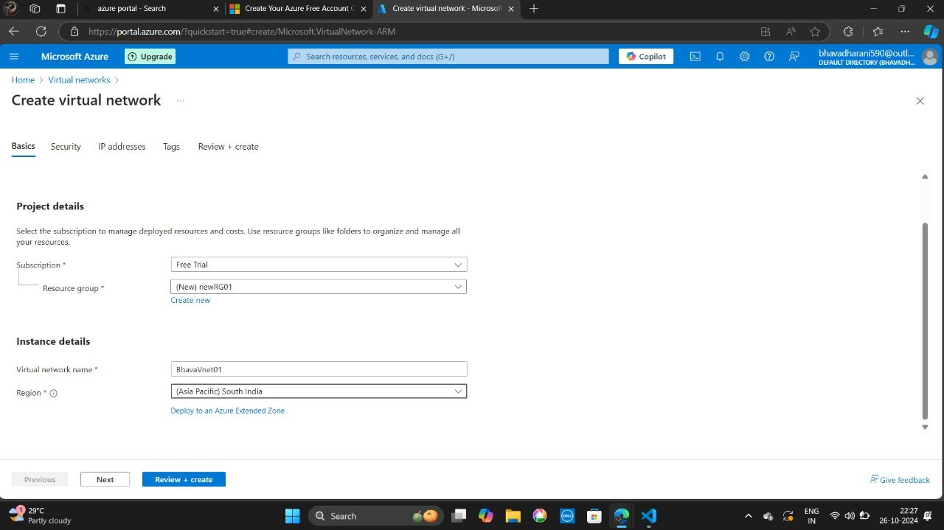

**Step 3:**

**Review and Deploy**

* Review your configurations and click **Create** to deploy the VM.

**Step 4:**

**SSH or RDP into the VM**

* Once the VM is created, navigate to the Overview tab and note the Public IP address.
* For Linux VMs, open a terminal and use the SSH command to connect.
* For Windows VMs, use RDP to connect by entering the public IP and using the credentials you set during the VM creation.

**Step 5:**

**Verify the Connection**

* **After successfully connecting, you can verify the operating system and ensure everything is running correctly.**

**Step 6:**

**Cloud Management Basics**

* You can now manage your VM, install software, run commands, or even explore the Azure portal for additional configurations (e.g., networking, storage).

